TITLE ONE COMMITTEE PRESENTS
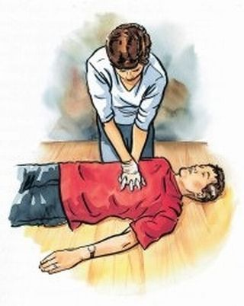
Program: HEARTSAVER ADULT/CHILD 4 HOURS
(Certification – valid 2yrs)

Date: Saturday, February 11, 2017

Time: 10:00am – 2:00pm

Location: Pablo Casals MS 181

If you would like to register for this training, please return the bottom portion to the Parent Coordinator, Ms. Brucia. Room 166
_____________________________________________________________________________________________
YES, I would like to register for the CPR Training on Saturday, Feb.11, 2017. I understand that a valid ID will be necessary for certification.
Name:________________________________ Date:_____________
Student:______________________________ Class:_____________
Phone:_______________________________ Email:_______________________________

