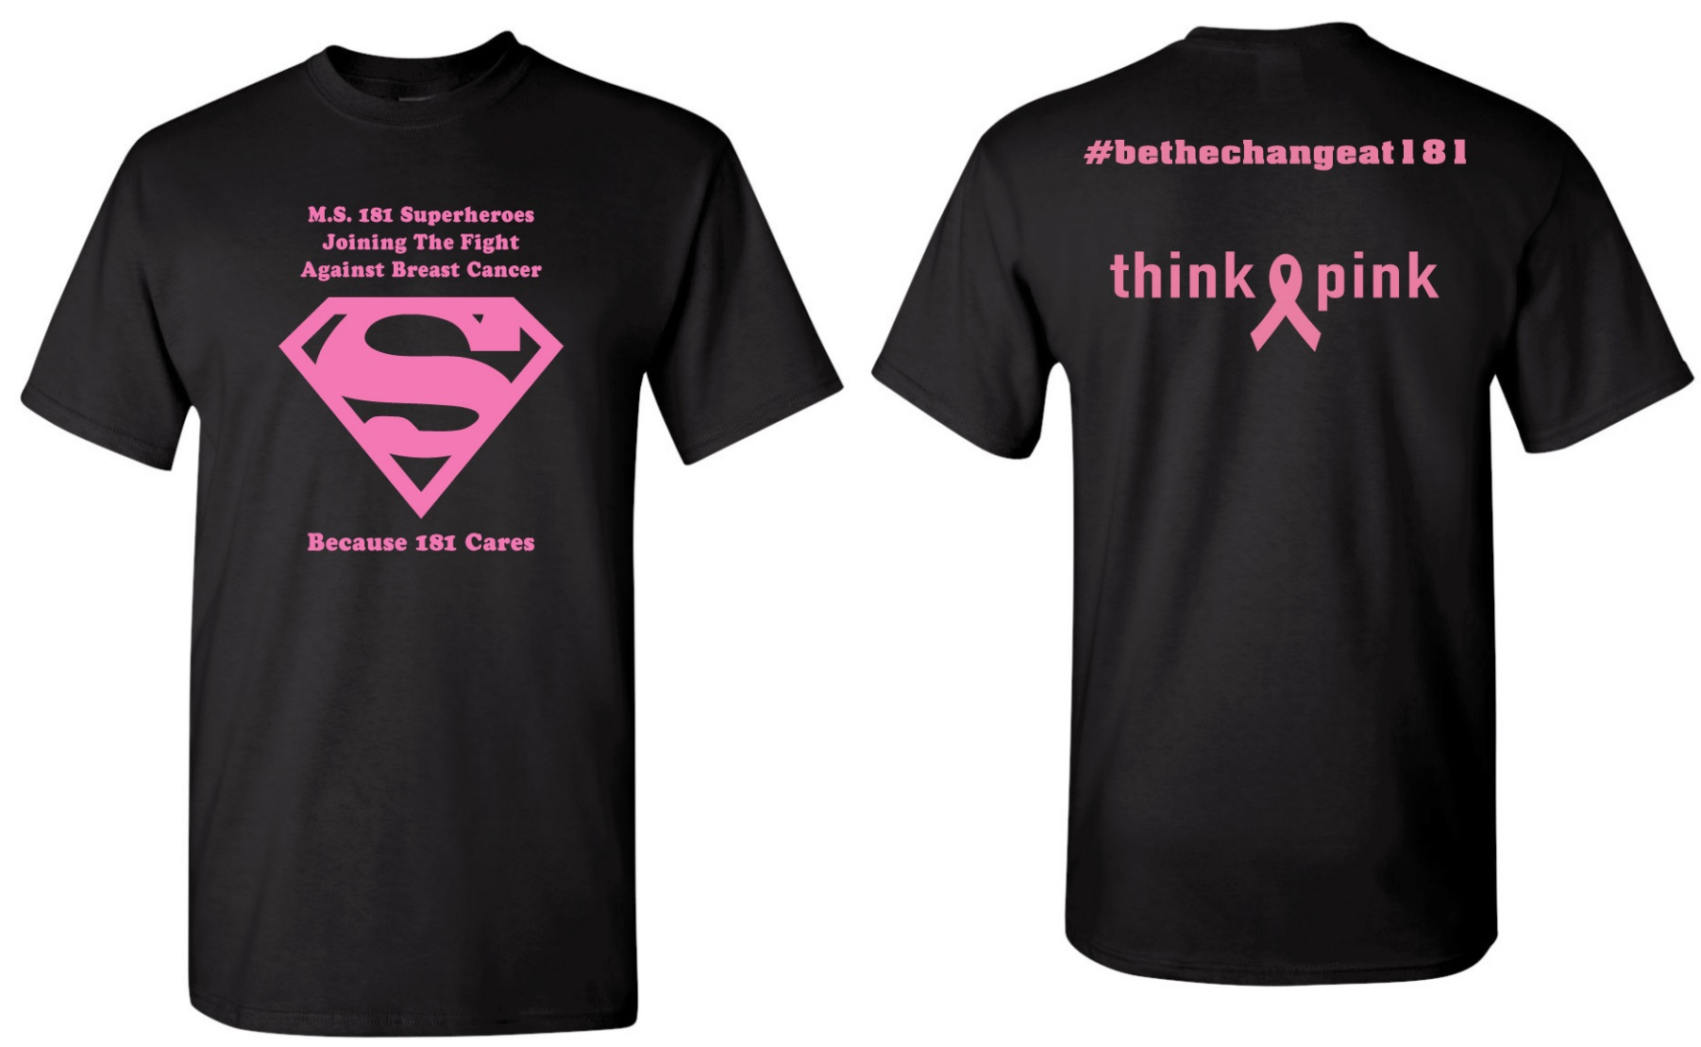

PURCHASE YOUR
M.S. 181
Strides For Breast Cancer
T-shirt
Must Order BY: October 7, 2019

